**How to upload large files to GitHub repository**

This article is solely for newbies in Github regarding how to push large files to your Github repository.

GitHub does not allow us to upload files larger than 25 megabytes through the browser. If you try you may get an error as follows.

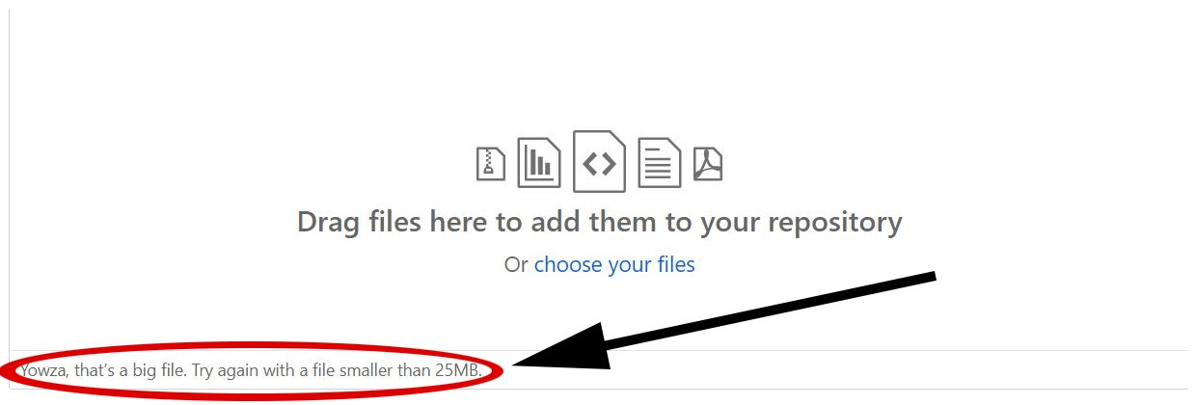

Figure 01: Error message (Image source: Screenshot by the [Author](https://pawara73.medium.com/))

Nevertheless, you can push larger files into your GitHub repository using the git bash terminal as follows, in just 8 steps.

**Step 01**

Download and install Git on your pc.

Download link:- <https://git-scm.com/downloads>

**Step 02**

Then download and install GitLFS on your pc.

Download link: <https://git-lfs.github.com/>

**Step 03**

Now clone your GitHub repository to your local machine.

For this,

First go to your repository and copy the ‘clone/download’ URL.

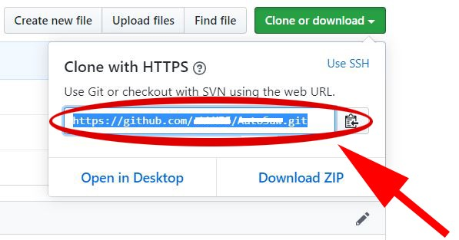

Figure02: Copy the clone or download URL (Image source: Screenshot by the [Author](https://pawara73.medium.com/))

Next, create a new folder in your pc wherever you prefer: this is to clone the copy of your GitHub repository to your pc.

Then right-click the background and click ‘Git Bash Here’ as follows.

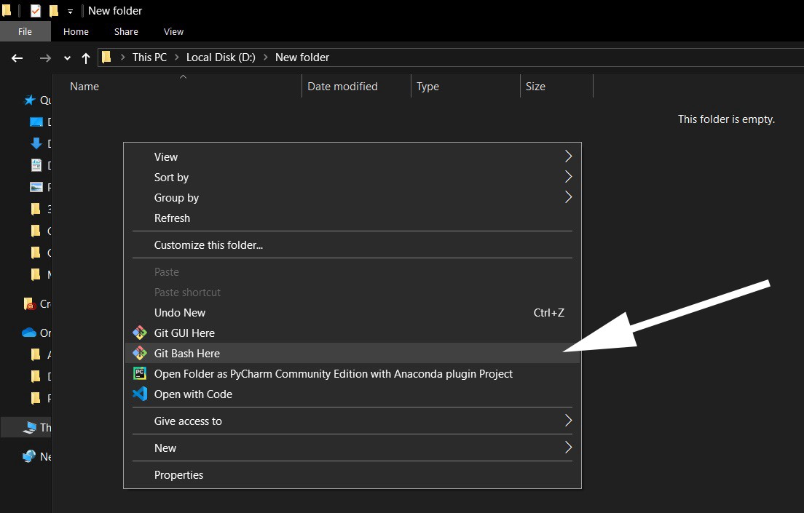

Figure 03: Opening Git Bash (Image source: Screenshot by the [Author](https://pawara73.medium.com/))

Then run the following command in the bash terminal opened.

$ **git** **clone** *link you copied*

Eg:- $ git clone https://github.com/Newuser/NewRepository.git

Close the bash terminal and, now you have successfully cloned your GitHub repository to your local machine.

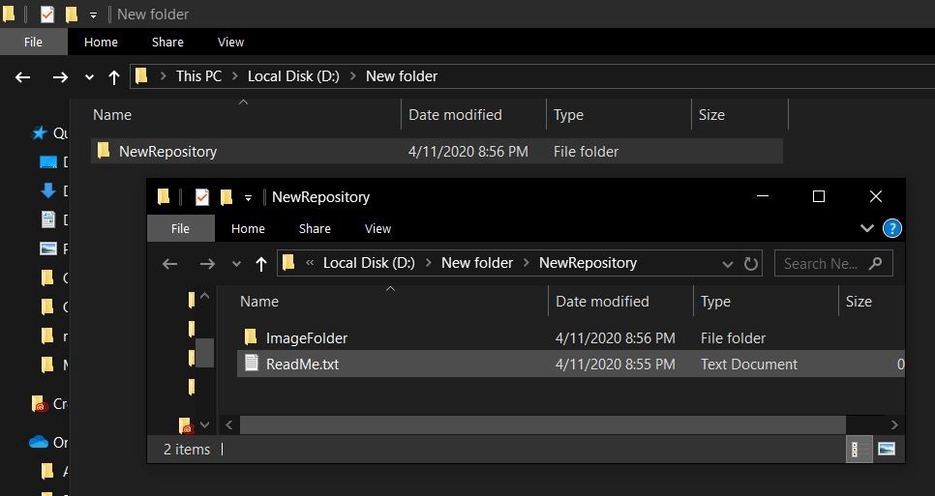

Figure 04: The repository named NewRepository has cloned to the local machine (Image source: Screenshot by the [Author](https://pawara73.medium.com/))

**Step 04**

Go to inside the cloned repository. (If you want to upload the file to another folder already created inside the repository, then go to that folder)

Right-click the background and again click ‘Git Bash Here’.

Run the following command

$ **git lfs track** “.*fileextension*”

Eg: If I want to upload a pdf file, then  
 $ git lfs track “.*apk*”

**Step 05**

Then copy the file you want to upload, into repository or folder in the repository.

**Step 06**

Then run the command,

$ **git add** *filename.fileextension*

Eg:- $ git add *TheGuid.apk*

**Step 07**

**We should log into GitHub to push the file to the repository, run the following commands.**

$ **git config --global user.email** *you@example.com*

Eg:- $ git config --global user.email “*123abc@gmail.com*”

For this use your email address used in Github account.

$ **git config --global user.name** “*your name*”

Eg:- $ git config --global user.name “George Bernard”

For this use your name in Github account. You can find your email and name in the settings of the Github account.

Then a window will pop out asking your Github email/user name and password. Enter the credentials and submit them.

**Step 08**

Now run the following command.

$ **git commit -m** "*commit message*"

Eg:- $ git commit -m “*add TheGuid.apk*”

Next,

$ **git lfs migrate import --include="*.apk"**

Next run,

$ **git push origin main**

This command will start the uploading the file.

You will notice the progress of the uploading in the bash terminal as follows

progress of file upload shown in bash terminal

Figure 05: Progress of file upload (Image source: Screenshot by the [Author](https://pawara73.medium.com/))

After uploading is finished, you may notice the file is uploaded to your GitHub repository, successfully.